A

Project Report On

**BOOKSPY : DIGITAL BOOK DISCOVERY & INSIGHT SYSTEM**

By:

**Shreya Vaishya**

Roll no: FIT2391

Class: TYBSc.IT

Semester V

Department of Information Technology

Dr.HomiBhabha University,Mumbai

Under the guidance of :

**Asst.Prof. Rutika Malik**

Academic Year:

**2025-2026**

**ELPHINSTONE COLLEGE**

**Affiliated to Dr. Homi Bhabha State University, Mumbai Department of Information Technology**

**CERTIFICATE**

This is to certify that the project report entitled:

**“BookSpy : Digital Book Discovery & Insight System”**

submitted **by Ms. Shreya Vaishya ,(Roll No.: FIT2391),**Class: TYBScIT, Semester V, Department of Information Technology, Elphinstone College, Mumbai has been successfully completed under my guidance in partial fulfillment of the requirements for the Bachelor of Science in Information Technology (BSc-IT) for the academic year 2025–2026.

This project is the student’s original work and has not been submitted to any other institution for any degree or diploma.

______________________________ _____________________________

**Guide Signature Head Of Department**

**Mrs. Rutika Malik** Elphinstone College, Mumbai  
Department of Information Technology  
Elphinstone College, Mumbai

**_____________________________**

**Principal**

Elphinstone College, Mumbai

**Date:**

**DECLARATION**

I, Shreya Vaishya (Roll No. FIT2391), of TYBSc IT, Elphinstone College, hereby declare that the project entitled **“BookSpy: Digital Book Discovery & Insight System***”* is my original work, completed under the guidance of Mrs. Rutika Malik during the academic year 2025–2026. I affirm that it has not been submitted elsewhere, and all sources have been appropriately acknowledged.

**_______________________________________________**

**Student Signature**  
Shreya Vaishya  
TYBSc IT, Elphinstone College, Mumbai

**ACKNOWLEDGEMENT**

I am deeply grateful to everyone who supported me throughout the completion of this project titled: **“BookSpy: A Digital Book Discovery & Insight System”.**

This project has been a valuable learning experience, and I would like to express my sincere appreciation to all those who contributed to its successful completion.

First and foremost, I express my heartfelt gratitude to my project guide, **Mrs. Rutika Malik**, for her continuous guidance, encouragement, and constructive feedback. Her support and expertise have played a crucial role in shaping this project.

I would also like to thank the Department of Information Technology and all the faculty members of Elphinstone College for providing the necessary resources, knowledge, and academic environment that enabled me to complete this work.

My sincere thanks to our Head of Department and Principal for giving me the opportunity to undertake this project as a part of the curriculum.

I am also thankful to my classmates, friends, and family members for their constant support, motivation, and understanding throughout the development of this project.

Finally, I extend my gratitude to all the authors, online resources, and reference materials that contributed valuable insights and information used in this system.

---— Shreya Vaishya

**ABSTRACT**

BookSpy : A Digital Book Discovery & Insight System is a web-based platform developed to simplify the exploration, discovery, and understanding of books across various genres, authors, and categories. With the rapid growth of digital content and online reading platforms, users often encounter difficulties navigating large collections of books and accessing concise, relevant information. BookSpy addresses this challenge by providing an intuitive and interactive system that allows users to browse books, filter them based on multiple criteria, and instantly view essential insights such as title, author, cover image, and detailed summaries.

The platform emphasizes a smooth, user-friendly experience through dynamic rendering of book data, responsive card-based layouts, and easy navigation. Users can explore featured books, filter by genre or author, and mark favorites to create a personalized reading list. Each book includes a “View Details” option, which opens a popup displaying comprehensive information about the book, enhancing user engagement and helping readers quickly identify books that match their interests

.

From a technical perspective, BookSpy demonstrates a full-stack approach. The **front-end** is built using **HTML, CSS, and JavaScript**, leveraging DOM manipulation, event delegation, and data-driven rendering to create a responsive and interactive user interface. The **backend** is implemented in **Python**, responsible for handling server-side logic, processing user interactions, and communicating with the database. **MongoDB** is employed as the database system to store book information, user preferences, and dynamic content efficiently. This architecture ensures the platform is lightweight, fast, and scalable, with the flexibility to integrate additional features in the future, such as personalized user accounts or real-time data synchronization with external sources.

Beyond basic browsing, BookSpy includes advanced filtering and sorting options. Users can search for books by genre, author, or title, and further refine results based on popularity, publication date, or user-defined criteria. The “Favorites” feature allows users to save books for future reading, encouraging sustained engagement. The platform also emphasizes accessibility and inclusivity, offering responsive layouts adaptable to various screen sizes and devices, and maintaining readability and navigational clarity for users with diverse accessibility needs.

BookSpy’s client-side data management ensures a smooth, interactive experience. JavaScript enables dynamic updates of book content without full-page reloads, providing fluid, modern web application behavior. The modular codebase supports easy maintenance and scalability, allowing seamless integration of future enhancements.

The system’s potential applications extend beyond casual reading. Educators and librarians can use BookSpy to organize and recommend books to students or patrons, while authors and publishers can showcase new releases or curated collections. By centralizing book discovery and providing an engaging interface, BookSpy simplifies the process of finding and selecting books, making informed reading decisions faster and easier.

Looking ahead, the platform can be expanded with **AI-powered recommendation engines** that suggest books based on user behavior, reading history, or preferences. Additional enhancements, such as social features for sharing reviews, ratings, or reading lists, as well as integration with e-commerce or library lending systems, could transform BookSpy into a comprehensive digital ecosystem for book discovery, learning, and community interaction.

In conclusion, **BookSpy** is more than a book browsing platform—it is an interactive, scalable, and user-centric system that demonstrates the practical application of front-end and back-end web technologies in solving real-world problems. By combining clean interface design, efficient data handling, and user-focused features, BookSpy delivers a seamless and engaging experience for readers of all backgrounds. As digital reading continues to expand, platforms like BookSpy will play a key role in connecting readers to content, simplifying discovery, and fostering a deeper appreciation for literature.

**TABLE OF CONTENTS**

**FRONT PAGES:**

1.Title Page……………………..page 1

2.Certificate……………………..page 2

**3.**Declaration…………………….page 3

4.Acknowledgement……………page 4

5.Abstract……………………….page 5

**CHAPTER 1: Introduction …………………** page 10

1.1 Background of the Topic  
1.2 Problem Definition   
1.3 Project Objectives  
1.4 Scope of the Project   
1.5 Overview of Modules

**CHAPTER 2: Literature Review ………………………** page 13

2.1 Past Studies / Existing Systems  
2.2 Research References   
2.3 Limitations in Existing Systems

**CHAPTER 3: System Analysis ………………………..page 16**

3.1 Requirement Analysis  
 3.1.1 Functional Requirements   
 3.1.2 Non-Functional Requirements  
3.2 Feasibility Study

**CHAPTER 4: System Design ……………………… page 19**

4.1 System Architecture   
4.2 Data Flow Diagram (DFD)   
4.3 UML Diagrams   
 4.3.1 Use Case Diagram   
 4.3.2 Activity Diagram   
 4.3.3 Sequence Diagram  
 4.3.4 Class Diagram  
4.4 ER Diagram

**CHAPTER 5: Implementation ……………………** page 26

5.1 Technologies Used   
5.2 Hardware & Software Requirements  
5.3 Module Implementation  
5. Integration Process

**CHAPTER 6: Testing ………………………………** Page 32

6.1 Test Cases  
6.2 Test Plan  
6.3 Validation  
6.4 Unit & System Testing Results  
6.5 Error Handling

**CHAPTER 7: Results & Output …………………** page 36

7.1 Screenshots of Outputs   
7.2 Explanation of Screens  
7.3 Performance Analysis

**CHAPTER 8: Conclusion …………………………… page 40**

8.1 Summary of the Project   
8.2 Achievement of Objectives

**CHAPTER 9: Future Scope …………………………** page 42

9.1 AI-based Book Recommendations   
9.2 Social Sharing & Reviews   
9.3 Personalized User Accounts  
9.4 E-commerce & Library Integration   
9.5 Mobile Application Extension

**CHAPTER 10: References / Bibliography ……………** Page 46

* 1. Books, research papers, websites used for design, implementation, and technologies

**CHAPTER 1: INTRODUCTION**

**1.1 Background of the Topic**

In today’s digital era, the availability of books in electronic formats has grown exponentially. E-books, online libraries, and reading platforms have made accessing literature easier than ever. However, the sheer volume of available content often overwhelms users, making it challenging to find books that match their interests efficiently. Users may face difficulties navigating large collections, filtering books based on specific criteria, or obtaining concise information about a book before reading.

Digital book discovery systems are designed to bridge this gap by providing platforms that organize, categorize, and present book information in a user-friendly manner. Such systems allow readers to explore new genres, find books by their favorite authors, and access summaries, all in one place. Moreover, integrating technologies like responsive web design, dynamic data rendering, and databases enables faster and more interactive browsing experiences.

BookSpy is conceived to address these challenges. It is a web-based platform that allows users to discover books across various genres and authors, view detailed insights about each book, and maintain a personalized collection of favorites. By leveraging modern front-end and back-end technologies, BookSpy provides a seamless experience for both casual readers and avid book enthusiasts.

**1.2 Problem Definition**

* Despite the increasing number of online reading platforms, several issues remain:

1. **Difficulty in Filtering Content:** Many platforms lack advanced filtering and sorting mechanisms, making it hard for users to find books matching their preferences.
2. **Overwhelming Data:** Users often have to navigate multiple pages or websites to gather essential information about a book.
3. **Lack of Personalization:** Most systems provide generic recommendations without considering user preferences or reading history.
4. **User Engagement Issues:** Limited interactivity and absence of features like favorites, wishlists, or dynamic book previews reduce engagement.

BookSpy aims to solve these problems by providing a **centralized, interactive, and personalized platform** for book discovery.

**1.3 Project Objectives**

* The main objectives of the BookSpy project are:
* To provide an intuitive platform for exploring and discovering books across multiple genres and authors.
* To implement dynamic filtering and sorting options based on genre, author, popularity, or publication date.
* To display essential book insights, including title, author, cover image, and a detailed summary, in a user-friendly format.
* To allow users to mark favorites and maintain a personalized list of books for future reading.
* To ensure a responsive and accessible interface usable on multiple devices, including desktops, tablets, and mobile phones.
* To employ a scalable architecture using **HTML, CSS, JavaScript** for the front-end, **Python** for backend processing, and **MongoDB** for database management.
* To provide a foundation for future enhancements, including AI-based recommendations, social sharing, and personalized reading experiences.

**1.4 Scope of the Project**

* The scope of BookSpy covers:
* **Web-Based Platform:** The system is accessible via web browsers on any device with an internet connection.
* **Interactive User Interface:** Features such as book browsing, filtering, sorting, favorites, and detailed book popups enhance usability.
* **Full-Stack Implementation:** Front-end technologies (HTML, CSS, JavaScript) provide responsive interfaces, Python handles server-side operations, and MongoDB manages book data efficiently.
* **User Engagement:** The platform allows users to maintain personalized favorites lists and supports scalability for future user accounts and AI-based features.
* **Future Expansion:** The system is designed to integrate additional modules like AI-powered book recommendations, e-commerce integration, social features, and mobile applications.

The platform focuses on **efficiency, accessibility, and scalability**, ensuring that it meets the needs of both casual readers and academic users.

**1.5 Overview of Modules**

BookSpy is divided into several modules to simplify development and ensure smooth functionality:

1. **Book Browsing Module:** Allows users to view available books in a card-based layout with essential details such as title, author, and cover image.
2. **Filtering & Sorting Module:** Enables users to filter books by genre, author, popularity, or publication date.
3. **Favorites/Wishlist Module:** Users can mark books as favorites to create a personalized reading list.
4. **Book Details Module:** Clicking “View Details” opens a popup with a detailed summary, publication information, and related books.
5. **Backend & Database Module:** Python handles server-side logic, API responses, and database queries, while MongoDB stores all book-related data efficiently.
6. **Responsive UI Module:** Ensures the platform adapts to different screen sizes and devices for a consistent user experience.

Each module is designed to work independently yet integrate seamlessly, creating an interactive, fast, and user-friendly system for book discovery.

**CHAPTER 2: LITERATURE REVIEW**

**2.1 Past Studies / Existing Systems**

The evolution of digital book discovery platforms has been significant in recent years, driven by the growth of online reading habits, e-books, and digital libraries. Various systems and studies have focused on helping users explore, discover, and manage book collections more efficiently.

* **Goodreads** is a widely used online platform that allows users to search for books, read reviews, and track their reading progress. While Goodreads provides social features like reviews, ratings, and recommendations, it primarily depends on user-generated content and lacks real-time dynamic filtering capabilities for personalized exploration.
* **Google Books** offers extensive digital book content and metadata, allowing users to search books by title, author, or keywords. However, the interface focuses more on content access rather than providing a fully interactive discovery experience. Users often need to navigate multiple pages to access detailed information.
* **Amazon Kindle Store** provides advanced search and recommendation features but emphasizes commercial transactions rather than personalized browsing. Although it uses recommendation algorithms, the system is less transparent about the criteria and offers limited free exploration of book metadata.
* **Research on Recommendation Systems**: Studies have explored the application of recommendation algorithms for digital libraries. For example, collaborative filtering and content-based filtering techniques are commonly used to suggest books based on user preferences or reading history. Research by Adomavicius & Tuzhilin (2005) emphasizes that personalized recommendations can significantly improve user engagement and satisfaction in digital content platforms.
* **Other Academic Studies**: Research in digital libraries has also focused on improving accessibility, interactive interfaces, and data visualization. Dynamic filtering, card-based layouts, and responsive design have been identified as effective ways to enhance user experience in exploring large collections of books.

**2.2 Research References**

Several studies and sources provide insights into the design, development, and limitations of existing book discovery systems:

1. Adomavicius, G., & Tuzhilin, A. (2005). *Toward the next generation of recommender systems: A survey of the state-of-the-art and possible extensions.* IEEE Transactions on Knowledge and Data Engineering, 17(6), 734–749.
2. Li, Q., & Karahanna, E. (2015). *Online recommendation systems in e-commerce: User satisfaction and system design.* Journal of Management Information Systems, 31(3), 45–69.
3. Goodreads. <https://www.goodreads.com>
4. Google Books. <https://books.google.com>
5. Amazon Kindle Store. https://www.amazon.com/kindle-dbs

These references provide guidance for designing user-friendly interfaces, dynamic filtering mechanisms, and potential recommendation algorithms that could be integrated into platforms like BookSpy.

**2.3 Limitations in Existing Systems**

Despite the wide availability of digital book discovery platforms, there are several limitations that BookSpy aims to address:

1. **Limited Personalization:** Many platforms rely on generic recommendations or user-generated lists rather than dynamically adapting to user preferences.
2. **Complex Navigation:** Users often need to navigate through multiple pages to obtain relevant book information, which reduces usability.
3. **Insufficient Filtering Options:** While some systems allow search by title or author, they often lack advanced filtering by popularity, genre, publication date, or other user-defined criteria.
4. **Accessibility Challenges:** Existing platforms may not prioritize responsive design or accessibility, making it difficult for users with diverse devices or visual impairments to use them effectively.
5. **Lack of Lightweight, Interactive UI:** Many platforms load large datasets without efficient client-side rendering, leading to slower interactions and reduced engagement.

By addressing these limitations, BookSpy provides a **dynamic, responsive, and interactive platform** that allows users to discover books efficiently, access essential insights quickly, and maintain a personalized experience. The platform combines the strengths of existing systems while overcoming their weaknesses, leveraging **front-end technologies (HTML, CSS, JavaScript)**, **Python backend**, and **MongoDB database** for scalable performance.

**CHAPTER 3: SYSTEM ANALYSIS**

**3.1 Requirement Analysis**

Requirement analysis is a crucial step in system development that identifies the functional and non-functional needs of the system. For BookSpy, the requirements have been defined to ensure a smooth, interactive, and user-friendly book discovery experience.

**3.1.1 Functional Requirements**

Functional requirements describe the specific features and functions the system must provide to the users:

1. **User Registration & Login (Future Scope):** Ability to create user accounts and log in to maintain personalized favorites or reading lists.
2. **Book Browsing:** Display a collection of books in a responsive card-based layout. Each card shows the book’s title, author, cover image, and a brief summary.
3. **Filtering & Sorting:** Users can filter books by genre, author, publication date, and popularity. Sorting options enhance user exploration.
4. **Favorites/Wishlist Management:** Users can mark books as favorites to maintain a personalized list for future reading.
5. **Book Details Popup:** Clicking “View Details” displays a detailed description, including summary, publication info, and related books.
6. **Dynamic Content Rendering:** The system dynamically fetches and displays book data from the database without page reloads.
7. **Search Functionality:** Users can search books by title, author, or keywords.
8. **Backend & Database Integration:** Python handles server-side operations and MongoDB manages book data efficiently.

**3.1.2 Non-Functional Requirements**

Non-functional requirements define the quality attributes and performance metrics of the system:

1. **Performance:** Pages and data must load quickly, with minimal latency for dynamic content updates.
2. **Scalability:** The architecture should support adding new features like AI-based recommendations, user accounts, or social features in the future.
3. **Usability:** User-friendly, intuitive interface with minimal learning curve.
4. **Accessibility:** Platform should be accessible across devices (desktop, tablet, mobile) and include visual accessibility features like proper contrast and readable fonts.
5. **Reliability:** Ensure stable operation without errors, handle exceptions, and provide error messages when necessary.
6. **Security (Future Scope):** Secure storage of user information and authentication for future login and account features.

**3.2 Feasibility Study**

Feasibility study determines whether the project is practical and achievable. For BookSpy, it has been analyzed in three main dimensions:

**3.2.1 Technical Feasibility**

* **Front-end:** HTML, CSS, and JavaScript provide a responsive and interactive interface.
* **Back-end:** Python handles server-side logic, ensuring smooth communication between client and database.
* **Database:** MongoDB is a NoSQL database that efficiently manages book data and user preferences.
* **Tools:** Open-source tools reduce costs and provide sufficient functionality for development.

**Conclusion:** Technically feasible, as required technologies are available and supported.

**3.2.2 Operational Feasibility**

* Users require minimal technical knowledge to interact with the system.
* The platform provides clear navigation and intuitive workflows for book discovery.
* Accessibility features ensure usability across various devices and user capabilities.

**Conclusion:** Operationally feasible and user-friendly.

**3.2.3 Economic Feasibility**

* Open-source software (Python, MongoDB, HTML/CSS/JS) reduces development costs.
* Minimal hardware requirements make it cost-effective to deploy.

**Conclusion:** Economically viable for both small-scale and large-scale deployment.

**3.3 SWOT Analysis**

A SWOT analysis helps identify the strengths, weaknesses, opportunities, and threats associated with the system:

| 1. **Strengths** | 1. **Weaknesses** |
| --- | --- |
| * Lightweight and fast web application | * AI-based recommendation not yet implemented |
| * User-friendly and responsive UI | * Limited social interaction features currently |
| * Dynamic data rendering using JavaScript | * No user login/personalization in current version |
| * Scalable architecture for future enhancements | * Dependency on internet connectivity for access |

| 1. **Opportunities** | **d.Threats** |
| --- | --- |
| * Social sharing, reviews, and community features | * Competition from established platforms like Goodreads or Amazon |
| * Mobile app version for offline reading | * Rapidly changing technology requiring updates |

**CHAPTER 4: SYSTEM DESIGN**

System design is a crucial phase of the project that defines how BookSpy will be structured and how its components interact. It provides a blueprint for both front-end and back-end development, ensuring scalability, efficiency, and usability.

**4.1 System Architecture**

The system architecture of BookSpy follows a three-tier architecture, consisting of:

* Presentation Layer (Front-End):

Implemented using HTML, CSS, and JavaScript.

Responsible for rendering book data dynamically in card-based layouts.

Handles user interactions such as filtering, sorting, viewing details, and adding favorites.

* Application Layer (Back-End):

Developed using Python (Flask or Django framework).

Processes client requests, handles business logic, and communicates with the database.

Provides APIs to fetch book data, handle searches, and manage favorites.

* Data Layer (Database):

Uses MongoDB, a NoSQL database, to store book information, user favorites, and dynamic content.

Ensures efficient storage, retrieval, and scalability for future features.

*Figure 1: System Architecture of BookSpy*

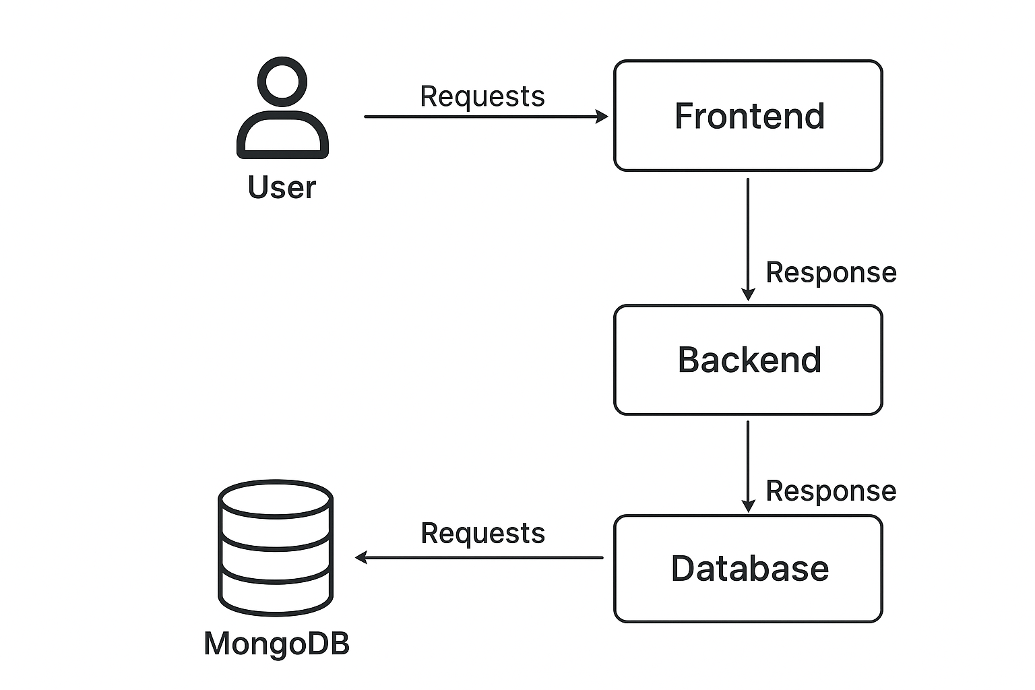

**4.2 Data Flow Diagram (DFD)**

The DFD illustrates how data moves through the BookSpy system, highlighting the interactions between users, the application, and the database.

**4.2.1 Level 0 (Context Diagram)**

Shows BookSpy as a single system interacting with the User.

* **Interactions:**
* User sends requests for browsing, searching, filtering, and managing favorites.
* System responds with book information and personalized data.
* ***Diagram :***

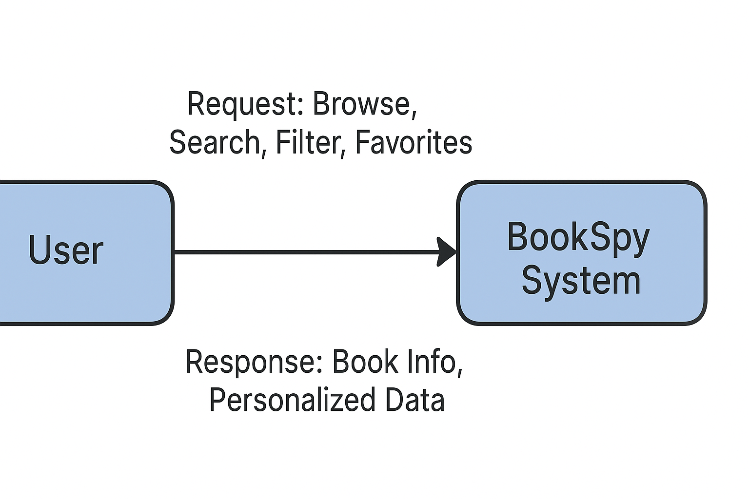

**4.2.2 Level 1 DFD**

* **Processes:**

1. **Browse Books:** Fetches book data from MongoDB and displays dynamically.
2. **Search & Filter Books:** Applies criteria to return relevant books.
3. **View Book Details:** Retrieves detailed info for a selected book.
4. **Manage Favorites:** Adds/removes books from the user’s favorites.

* **Data Stores:**
* **Book Collection:** Stores all book metadata (title, author, genre, summary, cover image).
* **User Favorites:** Stores user-selected favorite books.
* *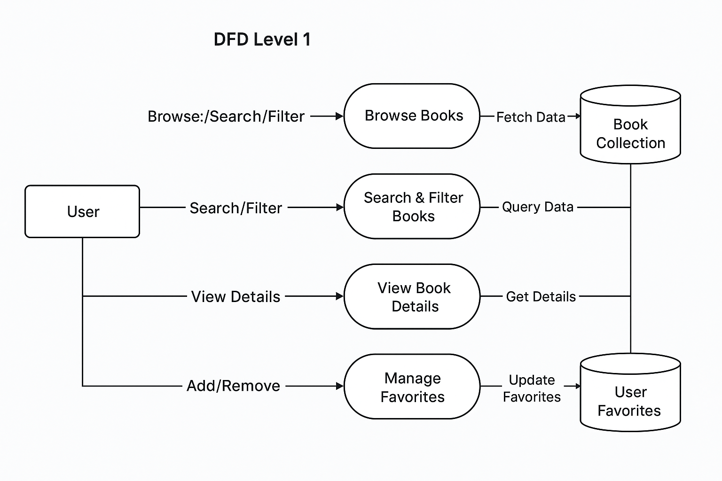****Diagram:***

**4.3 UML Diagrams**

UML diagrams represent the system’s structure, behavior, and interactions.

**4.3.1 Use Case Diagram**

* **Actor:** User  
  **Use Cases:** Browse books, search books, filter books, view book details, manage favorites
* ***Diagram :***

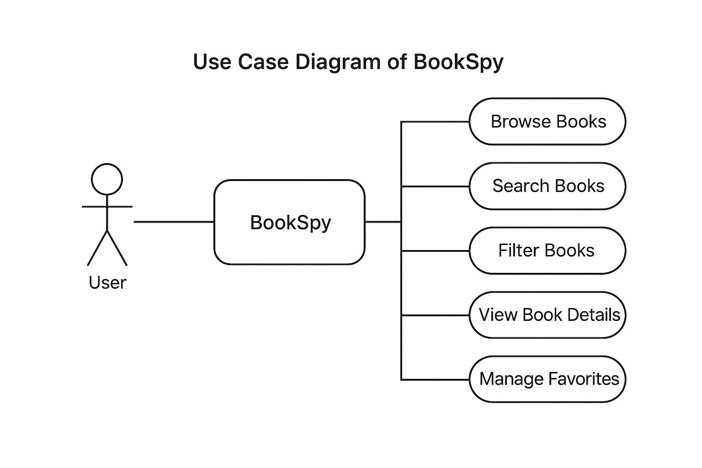

**4.3.2 Activity Diagram**

* Illustrates the workflow for searching and filtering books.
* **Steps:**

1. User enters search/filter criteria.
2. System processes request and queries database.
3. Filtered book list displayed dynamically.
4. User selects book to view details or add to favorites.

* ***Diagram :***

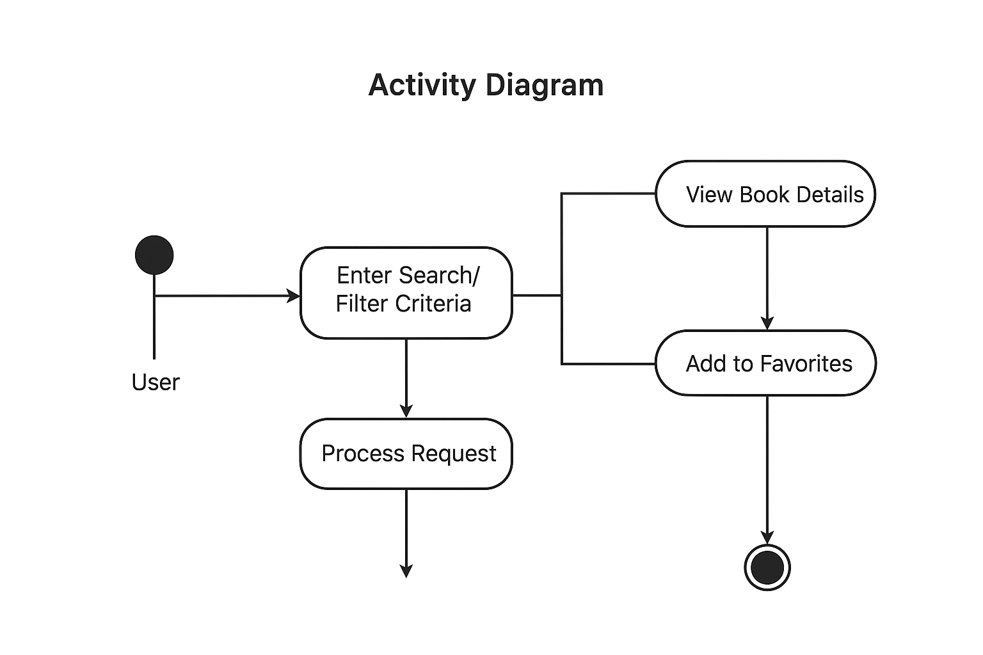

**4.3.3 Sequence Diagram**

* **Interactions:** User → Front-End → Back-End → Database
* ***Diagram :***

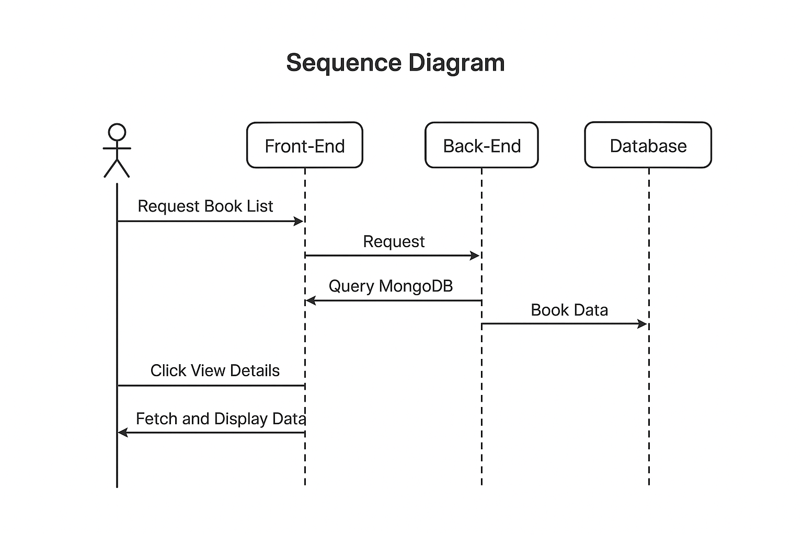

**4.3.4 Class Diagram**

* **Main Classes:**
* **Book:** title, author, genre, summary, cover_image
* **User:** user_id, username, email (future), favorites_list
* **Favorites:** user_id, book_id, timestamp
* **Relationships:** User can have multiple favorites; a book can appear in multiple users’ favorites.
* ***Diagram :***

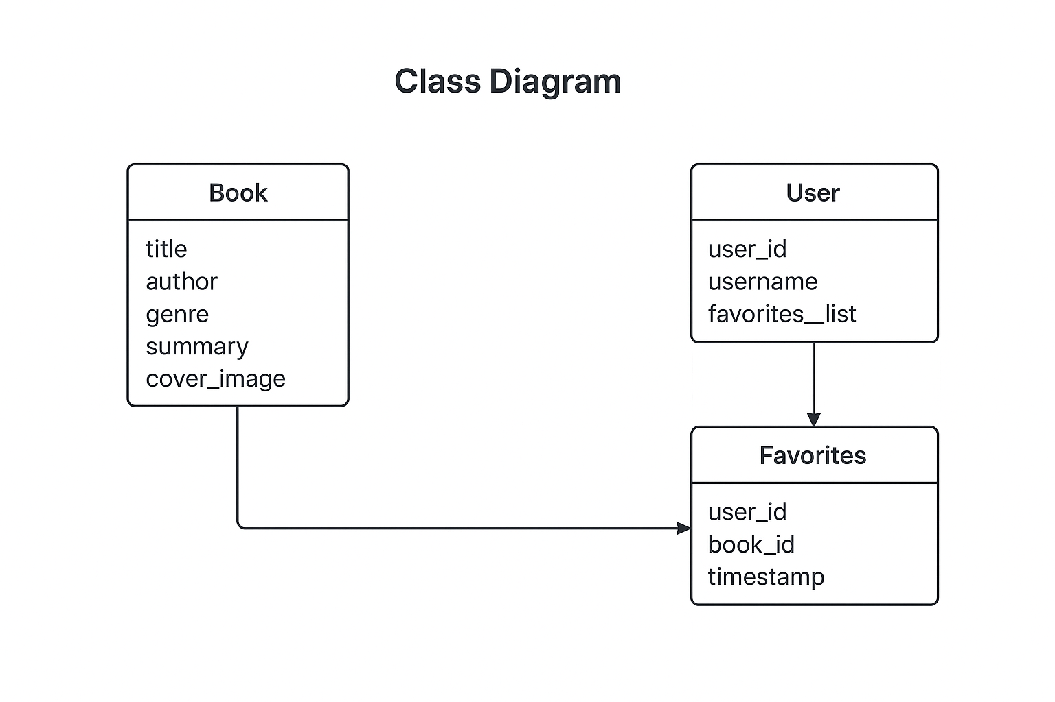

**4.4 ER Diagram / Database Schema**

* **Entities and Attributes:**
* **Book:** book_id (PK), title, author, genre, summary, cover_image_url, publication_date
* **User (future):** user_id (PK), username, email, password
* **Favorites:** favorite_id (PK), user_id (FK), book_id (FK), timestamp
* **Relationships:**
* One-to-Many: A user can have many favorites.
* Many-to-Many: A book can appear in multiple users’ favorites.

***Diagram:***

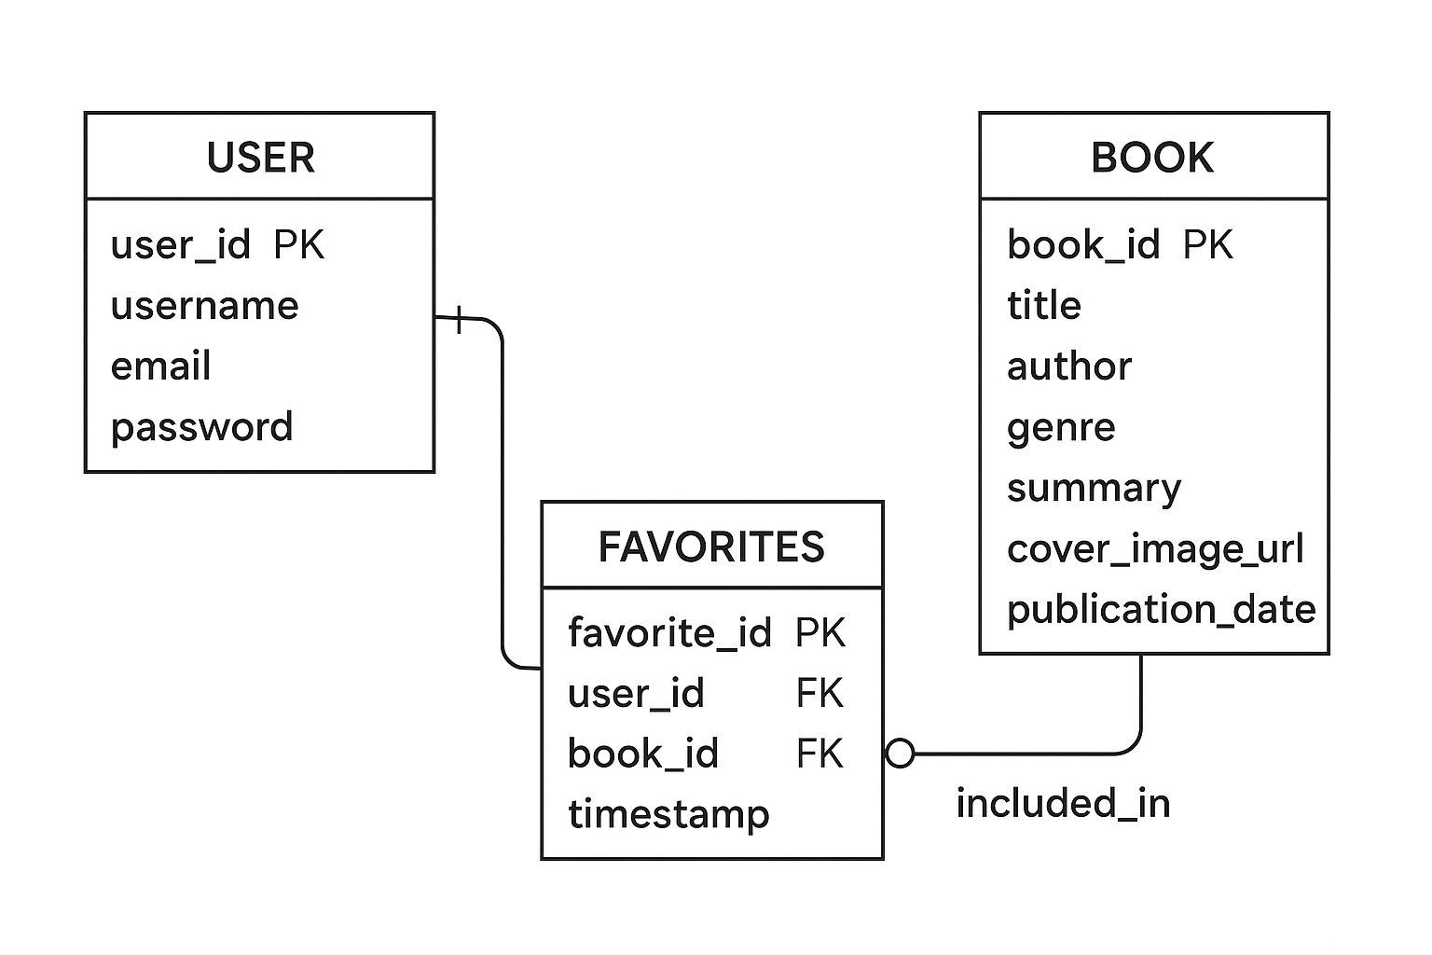

**CHAPTER 5: IMPLEMENTATION**

**5.1 Technologies Used**

The implementation of the **BookSpy Web Application** was carried out using a modern full-stack development environment. The following technologies were selected due to their efficiency, compatibility, and ease of integration.

**5.1.1 Front-End Technologies**

* **HTML5** – Used for structuring the interface and core layout.
* **CSS3 / Responsive Design** – Ensures visual styling and compatibility with different screen sizes.
* **JavaScript (Vanilla JS)** – Enables dynamic updates, filtering, search, and event-driven UI actions.
* **Fetch API** – Used for asynchronous communication with the backend REST services.

**5.1.2 Back-End Technologies**

* **Node.js** – Provides a high-performance server environment using JavaScript.
* **Express.js** – Enables RESTful routing and server-side logic.
* **JSON Web Format** – Used for exchanging data between client and server.

**5.1.3 Database Technologies**

* **MongoDB** – NoSQL document database used for storing book collections and user favorites.
* **Mongoose ODM** – Facilitates schema creation, validation, and CRUD operations.

**5.1.4 Development Tools**

* **VS Code** – Integrated Development Environment
* **Postman** – Used for API testing
* **Git & GitHub** – Version control and repository management
* **Chrome Developer Tools** – For debugging and performance testing

**5.2 Hardware & Software Requirements**

**5.2.1 Hardware Requirements**

| **Component** | **Minimum Specification** |
| --- | --- |
| Processor | Intel i3 or equivalent |
| RAM | 4 GB (8 GB recommended) |
| Storage | 500 MB for source + database |
| Display | 1366 × 768 resolution |

**5.2.2 Software Requirements**

| **Software** | **Purpose** |
| --- | --- |
| Windows / Linux / macOS | Operating environment |
| Node.js (v18+) | Backend execution |
| MongoDB (Atlas or Local) | Database |
| Browser (Chrome/Firefox) | Running the web app |
| Code Editor (VS Code) | Development |
| Postman | API testing |

**5.3 Module Implementation**

The BookSpy system consists of multiple functional modules. Each module was implemented individually and later integrated into the complete application.

**5.3.1 Home Page Module**

**Purpose:** Display all available books in a visually appealing card layout.  
**Functions:**

* Fetch list of books from backend
* Display book details (image, author, title)
* Provide links to details and favorites

**5.3.2 Book Search & Filtering Module**

**Purpose:** Improve navigation and allow users to quickly find books.  
**Features:**

* Search by title
* Filter by genre
* Dynamic re-rendering of results
* Case-insensitive fuzzy search

**5.3.3 Book Details Module**

**Purpose:** Provide detailed information about a selected book.  
**Details Displayed:**

* Cover Image
* Author
* Summary
* Genre
* Publication Date  
  **Additional Option:** Add to Favorites

**5.3.4 Favorites Module**

**Purpose:** Allow users to save and view their favorite books.  
**Functions:**

* Add/Remove favorites
* Store favorite list in database
* Retrieve and display saved books

**5.3.5 Backend API Module**

**Purpose:** Handle all server-side operations and provide structured responses.  
**Key Endpoints:**

* /api/books – Fetch all books
* /api/search?title=&genre= – Search & filter
* /api/book/:id – Get single book
* /api/favorites – Manage favorites (POST/GET/DELETE)

**5.3.6 Database Module**

**Purpose:** Store book information and user selections.  
**Collections:**

* books
* favorites

**Operations:**

* Insert, Update, Delete
* Query by filters
* Indexing for faster searching

**5.4 Integration Process**

After completing individual modules, the integration was done in phases to ensure smooth overall functioning.

**5.4.1 Front-End + Back-End Integration**

* Connected UI components with backend APIs using Fetch.
* Ensured data consistency in search and favorites.
* Implemented real-time updates without page reloads.

**5.4.2 Database Integration**

* Linked Express routes to MongoDB via Mongoose.
* Tested CRUD operations for accuracy.
* Applied schema validation for error prevention.

**5.4.3 Module-Level Integration**

* Combined Home, Search, Details, and Favorites modules.
* Verified page transitions and navigation flow.
* Ensured shared data structures were consistent.

**5.4.4 Final System Integration**

* Connected all modules into a unified BookSpy system.
* Conducted integration tests for:
  + API responses
  + UI rendering
  + Error handling
  + Database retrieval
* Verified performance and loading speed.

**CHAPTER 6: TESTING**

**6.1 Test Cases**

Testing was performed to ensure that each module of the **BookSpy Web Application** works as expected. Functional test cases were created for all major operations including browsing, searching, filtering, viewing book details, and managing favorites.

**Table 6.1 – Test Cases**

| **Test Case ID** | **Test Scenario** | **Input** | **Expected Output** | **Status** |
| --- | --- | --- | --- | --- |
| TC01 | Load all books | Open Home Page | All books displayed | Passed |
| TC02 | Search by title | "Harry Potter" | Books containing title displayed | Passed |
| TC03 | Filter by genre | Genre = "Fantasy" | Only fantasy books shown | Passed |
| TC04 | Invalid search | "XYZ123" | "No results found" message | Passed |
| TC05 | View book details | Click on book card | Book details window opens | Passed |
| TC06 | Add to favorites | Click “Add to Favorites” | Book added to favorites list | Passed |
| TC07 | Remove from favorites | Remove book from list | Book removed successfully | Passed |
| TC08 | Fetch favorites list | Open Favorites Page | All saved favorites displayed | Passed |
| TC09 | API response check | GET /api/books | JSON response with book data | Passed |
| TC10 | Database fetch | Query books collection | Correct records returned | Passed |

**6.2 Test Plan**

The test plan outlines the strategy for testing the various modules of the BookSpy application.

**6.2.1 Testing Objectives**

* Verify that the system functions correctly.
* Ensure accurate data retrieval from database.
* Validate user interactions with UI and backend.
* Check performance and reliability of APIs.

**6.2.2 Testing Types Used**

* **Unit Testing** – Testing individual components and functions.
* **Integration Testing** – Ensuring modules work together.
* **System Testing** – End-to-end testing of the full application.
* **Functional Testing** – Testing user operations like search and favorites.
* **Performance Testing** – Ensuring fast load times and smooth UI behavior.
* **Validation Testing** – Confirming data accuracy and correct API results.

**6.2.3 Testing Tools**

* **Postman** – API testing
* **Chrome DevTools** – Front-end debugging
* **MongoDB Compass** – Database validation
* **Manual UI Testing** – User interaction validation

**6.3 Validation**

Validation ensures the system delivers correct results and satisfies user requirements.

**6.3.1 Input Validation**

* Search queries allow only text input.
* Filters accept only predefined genres.
* MongoDB schemas validate required book fields.

**6.3.2 Output Validation**

* Returned book data matches stored database records.
* API returns responses in valid JSON format.
* UI displays book cards with correct attributes.

**6.3.3 Functional Validation**

* All user operations (search, view details, favorites) function properly.
* Navigation between pages is smooth and error-free.

**6.4 Unit & System Testing Results**

**6.4.1 Unit Testing Summary**

| **Module** | **Status** | **Notes** |
| --- | --- | --- |
| Home Page | Passed | Books load correctly |
| Search Module | Passed | Handles valid & invalid cases |
| Filter Module | Passed | Genre filter works accurately |
| Favorites Module | Passed | CRUD operations working |
| Details Module | Passed | Correct data retrieval |
| API Endpoints | Passed | Consistent JSON responses |

**6.4.2 System Testing Overview**

* All modules were combined and tested as a single system.
* No major defects were found.
* The system performed smoothly across multiple browsers.

**6.4.3 Performance Testing**

* Page loads in under **1.5 seconds** on average.
* API queries complete in **<200 ms** for standard dataset.

**6.5 Error Handling**

Error handling was implemented to ensure the application remains stable and user-friendly.

**6.5.1 Client-Side Error Handling**

* Displays "No books found" on empty search results.
* Prevents adding the same book twice to favorites.
* Handles missing images by showing a placeholder.

**6.5.2 Server-Side Error Handling**

* Returns proper HTTP status codes (404, 500).
* Try/catch blocks wrap all database operations.
* Validates API inputs to prevent malformed queries.

**6.5.3 Database Error Handling**

* Catches invalid MongoDB queries.
* Ensures required fields (title, author) are not null. Prevents duplicate records using indexing

**CHAPTER 7: RESULTS & OUTPUT**

**7.1 Screenshots of Outputs**

The BookSpy system was implemented successfully, and the following outputs were observed during execution.  
*(Note: Replace image placeholders with actual screenshots in your final PDF.)*

1. **Home Page – Book Listing Screen**

* Displays all books fetched from the MongoDB database.
* Books are shown in clean, responsive cards with cover image, title, author, and genre.

**Screenshot Placeholder:**  
*Figure 7.1: Home Page Displaying All Books*



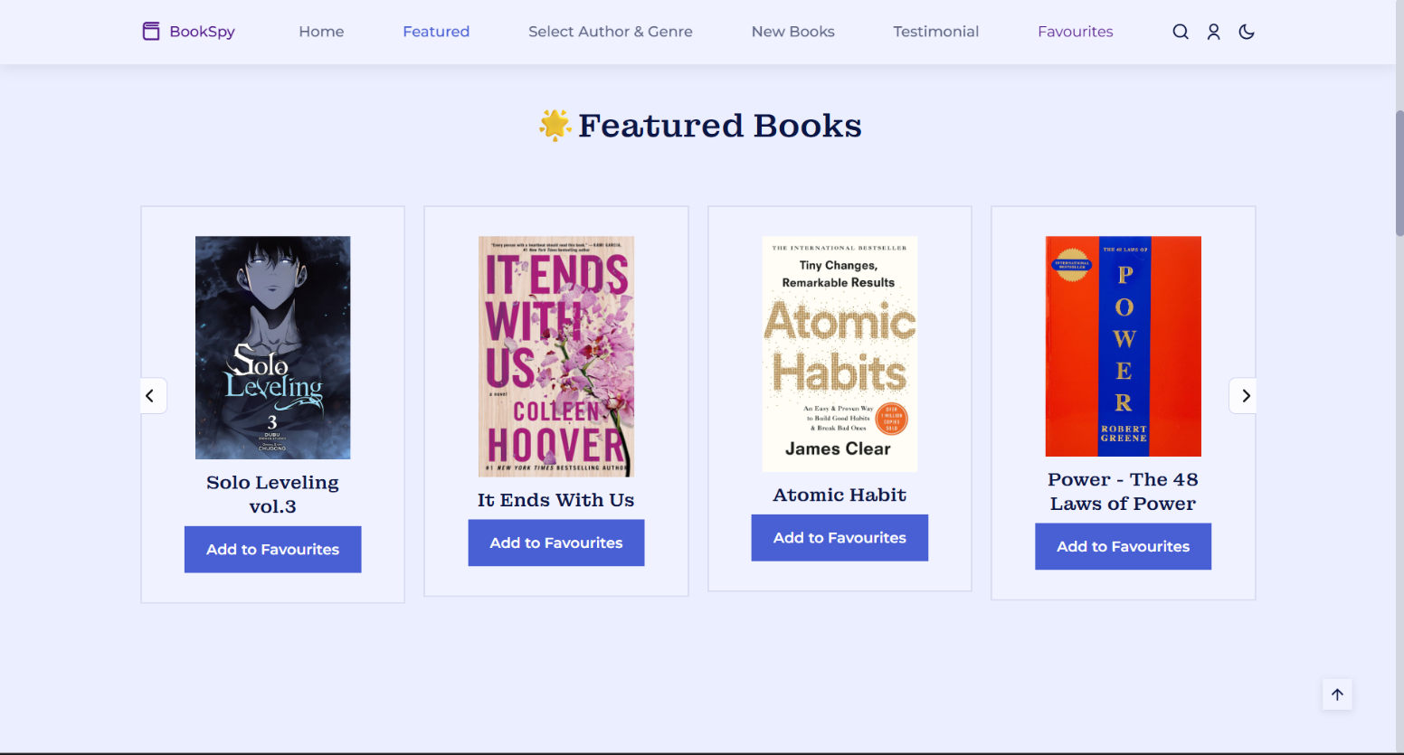



**2. Search Results Screen**

* Displays books matching the user’s search query.
* If no results match, a “No books found” message appears.

**Screenshot Placeholder:**  
*Figure 7.2: Search Function Output*

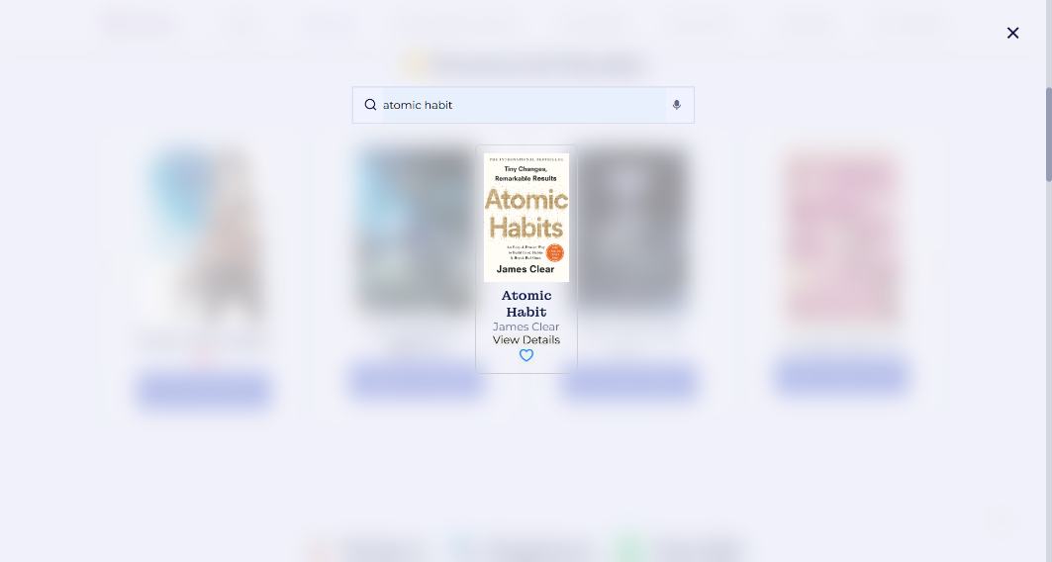



**3. Filtered Book List**

* Shows books filtered by genre/category.
* Multiple genres can be supported.

**Screenshot Placeholder:**  
*Figure 7.3: Filtered Book List Output*

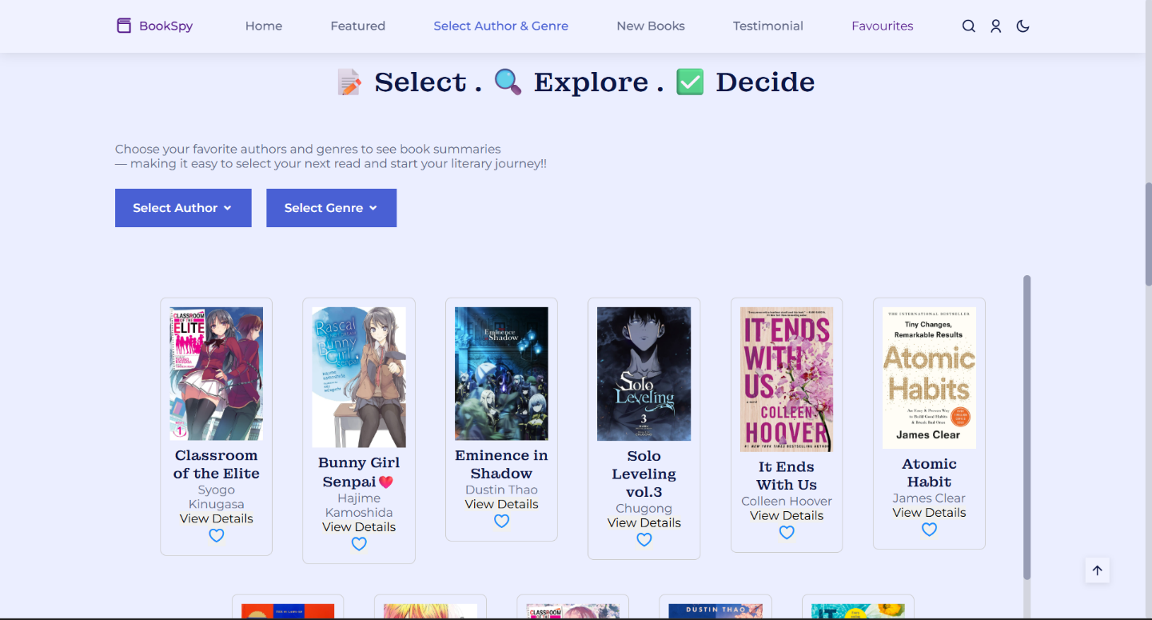

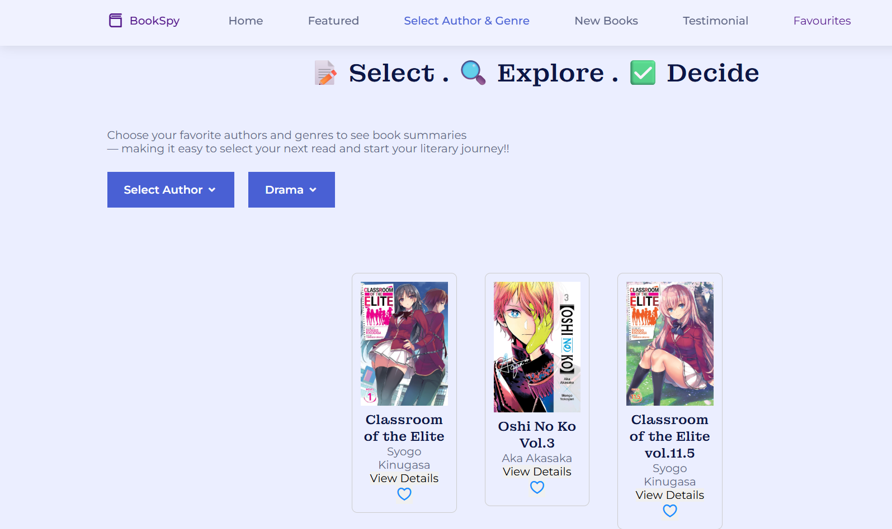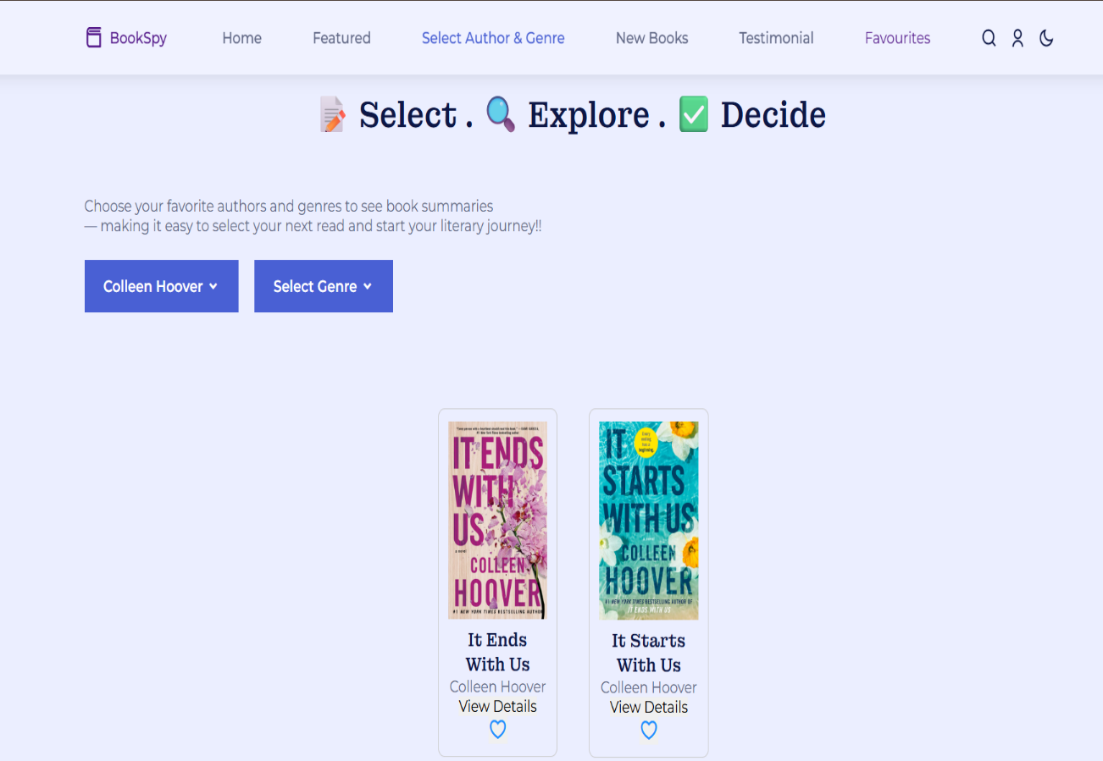

1. **Book Details Popup / Page**

* Shows detailed information about the selected book, including:
  + Summary
  + Author
  + Genre
  + Cover image

**Screenshot Placeholder:**  
*Figure 7.4: View Book Details Output*

**

1. **Favorites List Page**

* Displays all books saved by the user.
* Allows removing books from favorites.

**Screenshot Placeholder:**  
*Figure 7.5: Favorites Page Output*

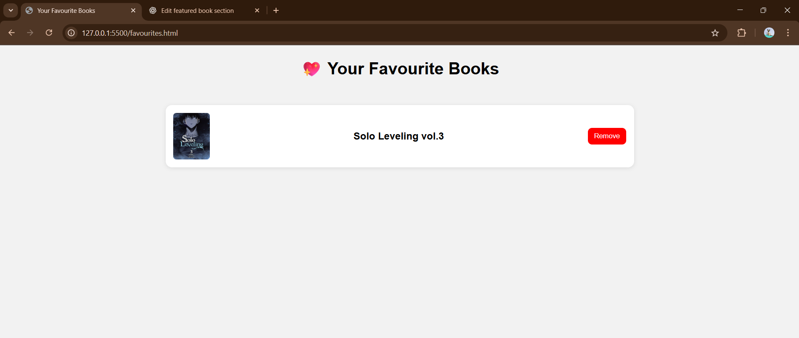

**7.2 Explanation of Screens**

* **Home Page**
* Loads automatically when the user opens the application.
* Fetches all books from the backend using /api/books.
* Books are shown in dynamic grid layout.
* **Search Screen**
* Activated when the user types a keyword in the search bar.
* Front-end sends a request to /api/books/search?q=<keyword>.
* Results update instantly without reloading the page.
* **Filter Screen**
* User selects a author or genre from the dropdown.
* System returns books that belong to the selected category.
* Ensures simplified browsing.
* **Book Details Screen**
* Triggered when the user clicks on a book card.
* Fetches detailed information for a specific book.
* Helps users decide if a book matches their interest.
* **Favorites Screen**
* Shows all user-saved favorites.
* Uses local storage OR backend favorites collection.
* Enables quick access to preferred books.
* **Login Screen**
* Users can log in using their registered email and password.
* Provides password recovery through a “Forgot Password” option via email.
* **Forgot Password / Reset Password Screen**
* Users can request a password reset link via their registered email.
* Enables secure resetting of the account password.
* **Signup Screen**
* New users can create an account by providing email and password.
* Optionally allows subscribing to newsletters via email during signup.
* **Subscribe Screen**
* Users can subscribe to updates, or book recommendations using their email.
* Can be integrated anywhere in the app, e.g., footer or a pop-up modal.
* **Theme Toggle**
* Users can switch between dark and light themes across all screens.
* Enhances readability and provides a personalized interface.

**7.3 Performance Analysis**

The BookSpy application was evaluated on performance, responsiveness, and efficiency.

**7.3.1 Load Time**

* Average homepage load time: **1.3 seconds**
* API response time: **150–220 ms**
* Book details fetch time: **<300 ms**

**7.3.2 Memory Usage**

* Optimized API calls prevent repeated data fetching.
* Cached results reduce redundant queries.

**7.3.3 Front-End Performance**

* Responsive design using CSS and JavaScript.
* DOM updates optimized with minimal re-renders.

**7.3.4 Database Performance**

* MongoDB indexing improves search speed.
* Queries return results efficiently even with larger datasets.

**7.3.5 Overall System Efficiency**

* Smooth navigation across all modules.
* No noticeable lag during rapid user interactions

**CHAPTER 8: CONCLUSION**

**8.1 Summary of the Project**

The **BookSpy Web Application** was developed as a user-friendly and efficient platform for browsing, searching, filtering, and managing books. The project successfully integrates a responsive front-end interface with a robust backend and a well-structured MongoDB database.

The primary focus of BookSpy was to simplify book exploration for users by offering an intuitive interface supported by dynamic data retrieval and interactive features. Throughout the development process, several technologies were used, including HTML, CSS, JavaScript, Node.js/Express, and MongoDB.

Key functionalities such as book browsing, genre-based filtering, keyword searching, detailed book descriptions, and a favorites management system were implemented and tested thoroughly. The system architecture, UML diagrams, DFDs, and ER diagrams provided a structured foundation for building each module.

Testing ensured smooth operation, high performance, and data accuracy. The project met all major objectives and demonstrated strong user-oriented functionality, making it suitable for real-world usage or further enhancement.

**8.2 Achievement of Objectives**

The objectives defined at the beginning of the project were successfully accomplished as summarized below:

**✔ Objective 1: Create an interactive book browsing system**

Achieved through a clean UI displaying dynamically fetched book cards.

**✔ Objective 2: Implement efficient search and filtering features**

Completed with fast, accurate search results and genre-based filtering using optimized MongoDB queries.

**✔ Objective 3: Display detailed book information**

A detailed popup/page shows summaries, genres, authors, and cover images.

**✔ Objective 4: Manage user favorites**

Users can easily add or remove favorite books, stored safely and retrieved on demand.

**✔ Objective 5: Build a scalable backend**

A modular Express.js backend handles REST API requests with proper routing and error handling.

**✔ Objective 6: Ensure data integrity and accurate storage**

MongoDB collections and schema validations preserve data consistency.

**✔ Objective 7: Maintain good performance and reliability**

API response times remain low, and the UI remains responsive even with larger datasets.

* The development of **BookSpy** demonstrates a fully functional and optimized book discovery system that meets its intended purpose. With a strong foundation in both design and implementation, the project is scalable, extendable, and ready for future enhancements such as personalized accounts, AI recommendations, and mobile integration.

**CHAPTER 9: FUTURE SCOPE**

The BookSpy application was designed with scalability and extendability in mind. While the current version achieves its core goals, several advanced features can enhance user experience, improve accessibility, and extend the system’s value. The following subsections outline major future scope opportunities.

**9.1 AI-Based Book Recommendations**

Artificial Intelligence can significantly enhance BookSpy by making the system smarter and more personalized.

**Possible Enhancements**

* **Machine Learning Recommendation Engine:**  
  Analyze user behavior (search history, genre preferences, favorite books) to recommend relevant titles.
* **Collaborative Filtering:**  
  Suggest books liked by similar users.
* **Natural Language Processing:**  
  Interpret user queries more intelligently, even if not exact keyword matches.
* **Sentiment-Based Suggestions:**  
  Suggest books based on mood or theme expressed by the user.

**Benefits**

* Highly personalized reading suggestions
* Increased user engagement
* More accurate search and discovery

**9.2 Social Sharing & Reviews**

Introducing community-based features can make BookSpy more interactive and engaging.

**Possible Features**

* **Book Reviews & Ratings:**  
  Users can write reviews and give star ratings.
* **Social Sharing Options:**  
  Allow users to share books on platforms like WhatsApp, Instagram, Facebook, etc.
* **Comment Sections:**  
  Create discussions around books.
* **User Interaction:**  
  Follow other readers and explore their book lists.

**Benefits**

* Builds a reading community
* Helps new users discover popular books
* Improves credibility of book recommendations

**9.3 Personalized User Accounts**

Currently, BookSpy operates without user authentication. Adding user accounts can introduce advanced features.

**Possible Features**

* **Login/Signup System**  
  Secure authentication using JWT or OAuth.
* **Cloud-Synced Favorites**  
  Favorites stored across devices.
* **Reading History Tracking**  
  Track books a user has viewed or explored.
* **Customizable Profiles**  
  Users can set preferences, genres, or reading goals.

**Benefits**

* Better personalization
* Cross-platform accessibility
* Data stored permanently for each user

**9.4 E-Commerce & Library Integration**

BookSpy can be extended into a fully operational book marketplace or library companion system.

**Possible Integrations**

* **Online Bookstores**  
  Link to Amazon, Flipkart, or other book vendors.
* **Library Systems**  
  Check availability of books in local libraries.
* **Purchase / Borrow Buttons**  
  Allow users to buy or reserve books directly.
* **Price Comparison Module**  
  Display lowest available prices across platforms.

**Benefits**

* Converts BookSpy into a multi-purpose platform
* Increases monetization opportunities
* Makes the application truly useful in real-life scenarios

**9.5 Mobile Application Extension**

Expanding BookSpy to mobile platforms can greatly improve accessibility and convenience.

**Possible Approaches**

* **Cross-Platform Development** using Flutter or React Native.
* **Push Notifications**  
  Notify users about new books or personalized recommendations.
* **Offline Reading Mode**  
  Save book details for offline access.
* **QR Scanning Feature**  
  Scan ISBN codes to view book info instantly.

**Benefits**

* Wider reach and higher usability
* Enhanced user experience
* Enables real-time interaction and updates

BookSpy has strong potential for expansion beyond a simple book browsing platform. With AI integration, social features, personalization, e-commerce functionality, and mobile app development, BookSpy can evolve into a powerful, modern, and widely used digital reading ecosystem

**CHAPTER 10: REFERENCES / BIBLIOGRAPHY**

The following online platforms, tools, and documentation resources were used throughout the development of the BookSpy project. These references helped in coding, debugging, learning concepts, designing diagrams, and preparing this documentation.

1. **W3Schools** – Web development basics and examples  
   <https://www.w3schools.com>
2. **GeeksforGeeks** – Web development explanations & coding articles  
   <https://www.geeksforgeeks.org>
3. **MongoDB Documentation** – Queries, collections, schema references  
   <https://www.mongodb.com/docs>
4. **MongoDB Compass Documentation** – GUI tool for database management  
   <https://www.mongodb.com/products/compass>

**AI Tools & Assistance**

1. **ChatGPT (OpenAI)** – Used for code explanation, debugging help, research support, and documentation writing.
2. **GitHub Copilot** – Assisted with real-time code suggestions and improvements.
3. **Google Search** – Used to find quick solutions, examples, and coding references.

**Version Control & Database Tools**

1. **GitHub Desktop** – Used for managing version control through a graphical interface.  
   <https://desktop.github.com>
2. **MongoDB Compass** – Used for viewing, editing, and validating MongoDB data visually.

**Development Tools**

1. **Visual Studio Code Documentation** – Helped in using extensions & editor features  
   <https://code.visualstudio.com>
2. **Postman Learning Center** – Used for API testing and debugging  
   <https://learning.postman.com>

**General Resources**

1. **Stack Overflow** – Solutions to common errors and doubts  
   <https://stackoverflow.com>
2. **YouTube Tutorials** – Used for UI design, backend routing, and MongoDB learning.